SPARKLING

PROSECCO SPUMANTE BOTTER, ITALY

A zippy, refreshing and sherbet style fizz with delicate fruity notes and a soft creamy finish.

Bottle - £25.00 125ml - £4.75

BARON DE VILLEBOERG BRUT, FRANCE

From a champagne house based in Ville Sur Arce, deep in the south of Champagne. This sparkling has an elegant nose with notes of blossom and yellow fruits. A fresh and generous palate, with a fine balance and long finish with hints of pear.

Bottle - £44.95

ROSE

THE DEEP ZINFANDEL ROSE, USA

The perfect sipping rose for both hot summer days and cooler winter nights. Raspberry, strawberry and sweet melon fruit make this wine juicy and hugely enjoyable.

Bottle - £17.75. 125ml - £3.50 175ml - £4.50 250ml - £5.95

DEA DEL MARE PINOT GRIGIO ROSE, ITALY

A light and delicate dry rose with gentle hints of strawberry fruit and a sherbet touch. Soft, refreshing and uplifting.

Bottle - £17.75 125ml - £3.50 175ml - £4.50 250ml - £5.95

CRAZY TROPEZ ROSE, FRANCE

This deliciously fun and fruity little number is produced by Domaine Tropez. A sweeter style pale rose made from 70% grenache and 30% Cinsault.

Bottle - £23.00 125ml - £4.30 175ml - £5.85 250ml - £7.85

ULTIMATE PROVENCE, FRANCE

Layers of raspberry and strawberry fruit in the nose invite you to a gorgeous, yet spicy palate. A fresh wine with great acidity for food pairing, but roundness to enjoy on its own.

Bottle - £30.00

WHISPERING ANGEL, FRANCE

Pale pink in colour, it has flavours of red currant, dried flowers and spices on the nose, with a subtle herbal quality. Dry with bitter red fruit flavours, it has a firm finish with lingering notes.

Bottle - £33.00

RED

YALLAROO SHIRAZ, AUSTRALIA

This is a fresh, juicy, fruity Aussie Shiraz laden with black forest flavours. Delicious and easy drinking.

Bottle - £18.50 125ml - £3.70 175ml - £4.70 250ml - £6.25

LION RIDGE MERLOT, SOUTH AFRICA

Brambly and stalky with spicy hedgerow fruit flavours, this is a big juicy Merlot with plenty of guts and a decent punch. Ripe and fruity, a big juicy mouthful.

Bottle - £18.95 125ml - £3.95 175ml - £4.95 250ml - £6.50

AVANTI MELBEC, ARGENTINA

Soft red fruit notes with elegantly smooth tannins and a lingering finish. A great example of Argentina’s hallmark red wine.

Bottle - £18.95 125ml - £3.95 175ml - £4.95 250ml - £6.50

VOLPETTO CHIANTI RISERVA

A complex wine with a deep intensity of fruit and a long powerful finish. Well-structured and full-bodied.

Bottle - £27.00

COTES DU RHONE LA CIGALIERE, FRANCE

A wine with a pale, straw-yellow gleam, this Gavi offers delicate flower and fruit sensations with notes of linden blossom and peach. On the palate the wine is subtle, elegant, and refined. Crisp and zesty, with a balanced and lingering finish.

Bottle - £26.00

PINOT NOIR THE DUCHESS, NEW ZEALAND

This is a lively, young Pinot with ripe cherry and plum fruit flavours. Bright, ripe and fragrant, the inviting bouquet shows dark fruit and floral characters with subtle spicy complexity.

Bottle - £28.00

ALTA BALIZA CABERNET SAUVIGNON, CHILE

Attractive aromas of berries with mature red fruits and spices. The palate demonstrates a firm body and lasting finish.

Bottle - £16.95 125ml - £3.50 175ml - £4.50 250ml - £5.95

CORMORAN RIOJA, SPAIN

Bright cherry red with masses of redberry fruit flavours leading into richer, warmer fruits with a hint of vanilla. Well-balanced, lingering and harmonious.

Bottle - £18.50 125ml - £3.55 175ml - £4.70 250ml - £6.25

WHite

DANGER BAY SAUVIGNON BLANC, SOUTH AFRICA

A vibrant expressive Sauvignon Blanc from the sunny western cape. Premium parcels of fruit had selected from cooler coastal vineyard sites.

Bottle - £ 125ml - £ 175ml - £ 250ml - £

DEA DEL MARE CATARRATTO PINOT GRIGIO, ITALY

Crisp dry wine has all the hallmarks of pinot grigio. Citrus fruits on the nose with a refreshing palate of zesty green apple balanced by the subtle minerality from Catarratto

Bottle - £ 125ml - £ 175ml - £ 250ml - £

BILLYCAN CHARDONNAY, AUSTRALIA

Australia has moved away from heavy, oaky, simple white wines and this Chardonnay shows their new improved style. Light and fresh with crisp green apple character.

Bottle - £ 125ml - £ 175ml - £ 250ml - £

LA SERRE VIOGNIER, FRANCE

The nose is full of peach and apricot fruit and almond aromas. The palate is both refreshing yet weighty with a smooth and round finish.

Bottle - £

PAOLA SORDO GAVI, ITALY

A wine with a pale, straw-yellow gleam, this Gavi offers delicate flower and fruit sensations with notes of linden blossom and peach. On the palate the wine is subtle, elegant and refined. Crisp and zesty, with a balanced and lingering finish.

Bottle - £

GRAND’ARTE ALVARINHO, PORTUGAL

Real finesse with an intense aroma of ripe orchard fruits. The body is full of a delicious, creamy tropical character yet has a fresh, citrus quality and a long finish.

Bottle - £

ACQUAE PICPOL DE PINET, FRANCE

A dry white wine with a gold colour. A fine, fresh nose with fruity and floral aromas. A refreshing palate with hints of citrus.

Bottle - £

GRAVEL & LOAM SAUVIGNON BLANC, NEW ZEALAND

Intense gooseberry aromas alongside fresh herbaceous and grassy notes. Vibrant passion fruit, citrus and peach characters with top notes of melon and kiwi balanced with softer apple and white pear flavours.

Bottle - £ 125ml - £ 175ml - £ 250ml - £

MUSCADET DE SEVRE ET MAINE SUR LIE ‘BLEU’, FRANCE

Traditional, classic Muscadet meets modern day with this quirky bottle design and colour. Full and nicely balanced on the palate with a lingering finish. Bottle - £ 125ml - £ 175ml - £ 250ml - £

Dry crisp and fresh with a sea breeze and light almond character. Carries a light and easy natural style with a slight spritz and a great bottle.

Bottle

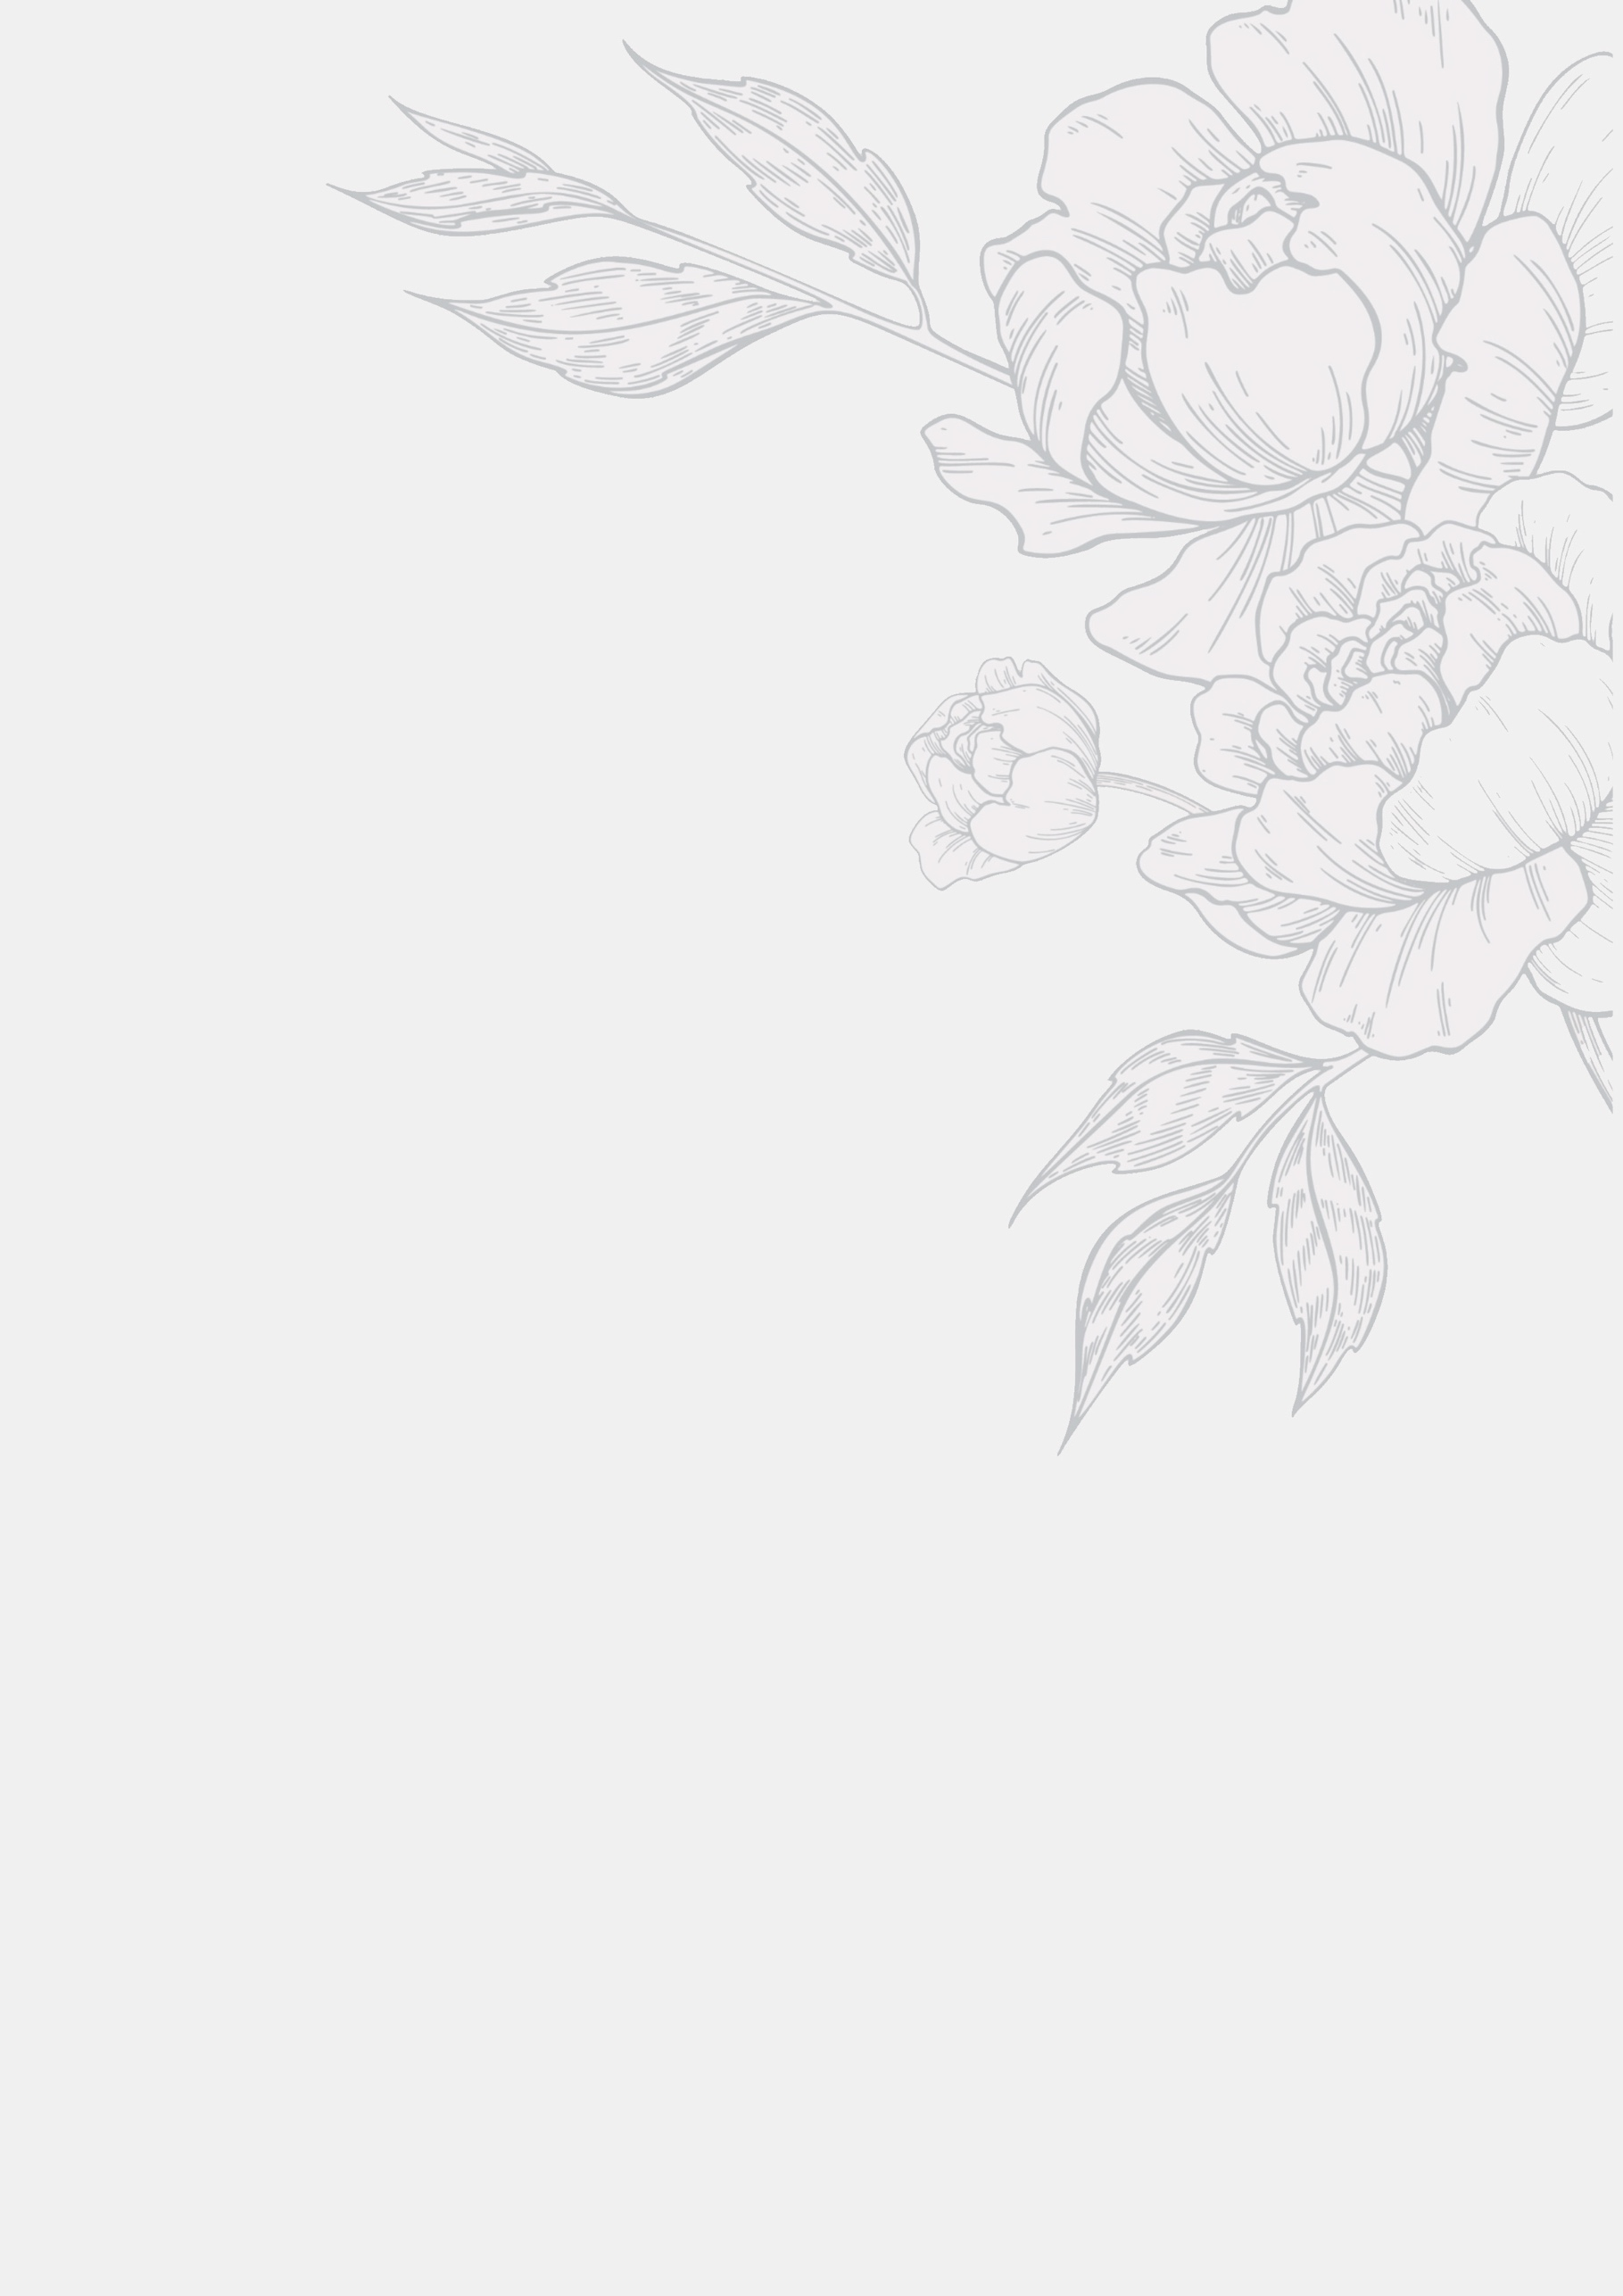

WHite

DANGER BAY SAUVIGNON BLANC, SOUTH AFRICA

A vibrant expressive Sauvignon Blanc from the sunny western cape. Premium parcels of fruit had selected from cooler coastal vineyard sites.

Bottle - £17.50 125ml - £3.50 175ml - £4.50 250ml - £5.95

INTORNO CATARRATTO PINOT GRIGIO, ITALY

Crisp dry wine has all the hallmarks of pinot grigio. Citrus fruits on the nose with a refreshing palate of zesty green apple balanced by the subtle minerality from Catarratto

Bottle - £17.50 125ml - £3.50 175ml - £4.50 250ml - £5.95

BILLYCAN CHARDONNAY, AUSTRALIA

Australia has moved away from heavy, oaky, simple white wines and this Chardonnay shows their new improved style. Light and fresh with crisp green apple character.

Bottle - £17.95 125ml - £3.60 175ml - £4.60 250ml - £6.00

LA SERRE VIOGNIER, FRANCE

The nose is full of peach and apricot fruit and almond aromas. The palate is both refreshing yet weighty with a smooth and round finish.

Bottle - £19.95

PAOLA SORDO GAVI, ITALY

A wine with a pale, straw-yellow gleam, this Gavi offers delicate flower and fruit sensations with notes of linden blossom and peach. On the palate the wine is subtle, elegant and refined. Crisp and zesty, with a balanced and lingering finish.

Bottle - £28.00

GRAND’ARTE ALVARINHO, PORTUGAL

Real finesse with an intense aroma of ripe orchard fruits. The body is full of a delicious, creamy tropical character yet has a fresh, citrus quality and a long finish.

Bottle - £22.00

ACQUAE PICPOL DE PINET, FRANCE

A dry white wine with a gold colour. A fine, fresh nose with fruity and floral aromas. A refreshing palate with hints of citrus.

Bottle - £26.00

OUTNUMBERED SAUVIGNON BLANC, NEW ZEALAND

Intense gooseberry aromas alongside fresh herbaceous and grassy notes. Vibrant passion fruit, citrus and peach characters with top notes of melon and kiwi balanced with softer apple and white pear flavours.

Bottle - £24 125ml - £ 4.35 175ml - £5.90 250ml - £7.95

MUSCADET DE SEVRE ET MAINE SUR LIE ‘BLEU’, FRANCE

Traditional, classic Muscadet meets modern day with this quirky bottle design and colour. Full and nicely balanced on the palate with a lingering finish. Bottle - £24

Dry crisp and fresh with a sea breeze and light almond character. Carries a light and easy natural style with a slight spritz and a great bottle.

Bottle

RED

YALLAROO SHIRAZ, AUSTRALIA

This is a fresh, juicy, fruity Aussie Shiraz laden with black forest flavours. Delicious and easy drinking.

Bottle - £18.50 125ml - £3.70 175ml - £4.70 250ml - £6.25

LION RIDGE MERLOT, SOUTH AFRICA

Brambly and stalky with spicy hedgerow fruit flavours, this is a big juicy Merlot with plenty of guts and a decent punch. Ripe and fruity, a big juicy mouthful.

Bottle - £18.95 125ml - £3.75 175ml - £4.95 250ml - £6.50

AVANTI MELBEC, ARGENTINA

Soft red fruit notes with elegantly smooth tannins and a lingering finish. A great example of Argentina’s hallmark red wine.

Bottle - £18.95 125ml - £3.75 175ml - £4.95 250ml - £6.50

VOLPETTO CHIANTI RISERVA

A complex wine with a deep intensity of fruit and a long powerful finish. Well-structured and full-bodied.

Bottle - £27.00

COTES DU RHONE LA CIGALIERE, FRANCE

A wine with a pale, straw-yellow gleam, this Gavi offers delicate flower and fruit sensations with notes of linden blossom and peach. On the palate the wine is subtle, elegant, and refined. Crisp and zesty, with a balanced and lingering finish.

Bottle - £26.00

PINOT NOIR THE DUCHESS, NEW ZEALAND

This is a lively, young Pinot with ripe cherry and plum fruit flavours. Bright, ripe and fragrant, the inviting bouquet shows dark fruit and floral characters with subtle spicy complexity.

Bottle - £28.00

ALTA BALIZA CABERNET SAUVIGNON, CHILE

Attractive aromas of berries with mature red fruits and spices. The palate demonstrates a firm body and lasting finish.

Bottle - £16.95 125ml - £3.50 175ml - £4.50 250ml - £5.95

1000 MILHOJAS CRIANZA RIOJA, SPAIN

Bright cherry red with masses of redberry fruit flavours leading into richer, warmer fruits with a hint of vanilla. Well-balanced, lingering and harmonious.

Bottle - £18.50 125ml - £3.55 175ml - £4.70 250ml - £6.25